**NAME:**

**PAPER P**

**Date to be handed in:**

**MARK (out of 100):**

|  |  |  |  |  |  |  |  |  |  |  |  |  |  |  |  |
| --- | --- | --- | --- | --- | --- | --- | --- | --- | --- | --- | --- | --- | --- | --- | --- |
| **Qu** | **1** | **2** | **3** | **4** | **5** | **6** | **7** | **8** | **9** | **10** | **11** | **12** | **13** | **14** | **15** |
|  |  |  |  |  |  |  |  |  |  |  |  |  |  |  |  |

**Pure Mathematics**

**A Level: Practice Paper**

**Time: 2 hours**

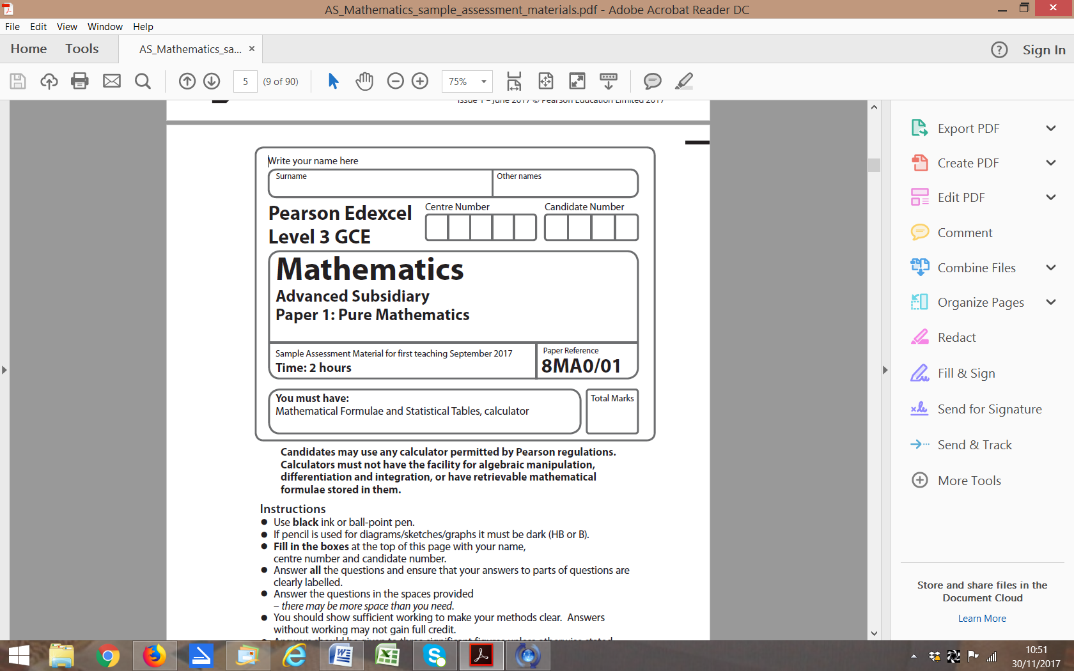

**Questions to revise:**

**1** The first 3 terms of a geometric sequence are , 

Find the value of *k*. **(4 marks)**

**2** The volume of a sphere *V* cm3 is related to its radius *r* cm by the formula

The surface area of the sphere is also related to the radius by the formula

Given that the rate of decrease in surface area, in cm2 s–1, is find the rate decrease of volume **(4 marks)**

**3** A curve *C* has parametric equations,,

Show that a cartesian equation of *C* isfor a suitable domain which should be stated.

**(4 marks)**

**4** Show that  can be written in the form 

Find the values of the constants *A* and *B*. **(5 marks)**

**5** A curve *C* has equation for *x* > 0

Find the exact value ofat the point *C* with coordinates (2, 4). **(5 marks)**

**6** Find the values of the constants *A*, *B*, *C*, *D* and *E* in the following identity:

 **(5 marks)**

**7** Given that in the expansion of  the coefficient of the *x*2 term is 75 find:

**a** the possible values of *a* **(4 marks)**

**b** the corresponding coefficients of the *x*3 term. **(2 marks)**

**8** A sequence is given by, where *p* is an integer.

**a** Show that **(2 marks)**

**b** Given that, find the value of *p*. **(3 marks)**

**c** Hence find the value of. **(1 mark)**

**9** The coordinates of *A* and *B* are (−1, 7, *k*) and (4, 1, 10) respectively.

**a** Given that the distance from *A* to *B* is units, find the possible values of the constant *k*.

**(3 marks)**

**b** For the larger value of *k*, findthe unit vector in the direction of . **(3 marks)**

**10** The functions f and g are defined by , *x*∈ℝ and , *x*∈ℝ, *x* > −1

**a** Find fg(*x*) and state its range. **(4 marks)**

**b** Solve fg(*x*) = 85 **(3 marks)**

**11** 

**a** Show that the equation f(*x*) = 0 can be written as,

where *a* and *b* are constants to be found.  **(2 marks)**

**b** Let *x*0 = 1.5. Use the iteration formula, together with your values of *a* and *b*

from part **a**, to find, to 4 decimal places, the values of *x*1, *x*2, *x*3 and *x*4. **(2 marks)**

A root of f(*x*) = 0 is *α*.

**c** By choosing a suitable interval, prove that *α* = −2.782 to 3 decimal places. **(3 marks)**

**12 a** Show that **(4 marks)**

**b** Hence find the exact value of **(5 marks)**

**13 a** Use proof by contradiction to show that if *n*2 is an even integer then *n* is also an even integer.

**(4 marks)**

**b** Prove thatis irrational. **(6 marks)**

**14** The value of a computer, *V*, decreases over time, *t*, measured in years.

The rate of decrease of the value is proportional to the remaining value.

**a** Given that the initial value of the computer is *V*0 , show that **(4 marks)**

After 10 years the value of the computer is

**b** Find the exact value of *k*. **(3 marks)**

**c** How old is the computer when its value is only 5% of its original value?

Give your answer to 3 significant figures. **(3 marks)**

**15** **a** Express 5 cos *θ* − 8 sin *θ* in the form *R* cos (*θ + α*) where *R* > 0 and 0 < *α* < π

Write *R* in surd form and give the value of *α* correct to 4 decimal places. **(4 marks)**

The temperature of a kiln, , used to make pottery can be modelled by the equation  where *x* is the time in hours since the pottery

was placed in the kiln.

**b** Calculate the maximum value of *T* predicted by this model and the value of *x*, to 2 decimal places,

when this maximum first occurs. **(4 marks)**

**c** Calculate the times during the first 24 hours when the temperature is predicted, by this model,

to be exactly 1097 °C. **(4 marks)**

**(TOTAL: 100 MARKS)**