**NAME:**

**PAPER Q**

**Date to be handed in:**

**MARK (out of 100):**

|  |  |  |  |  |  |  |  |  |  |  |  |  |  |  |  |
| --- | --- | --- | --- | --- | --- | --- | --- | --- | --- | --- | --- | --- | --- | --- | --- |
| **Qu** | **1** | **2** | **3** | **4** | **5** | **6** | **7** | **8** | **9** | **10** | **11** | **12** | **13** | **14** | **15** |
|  |  |  |  |  |  |  |  |  |  |  |  |  |  |  |  |

**Pure Mathematics**

**A Level: Practice Paper**

**Time: 2 hours**

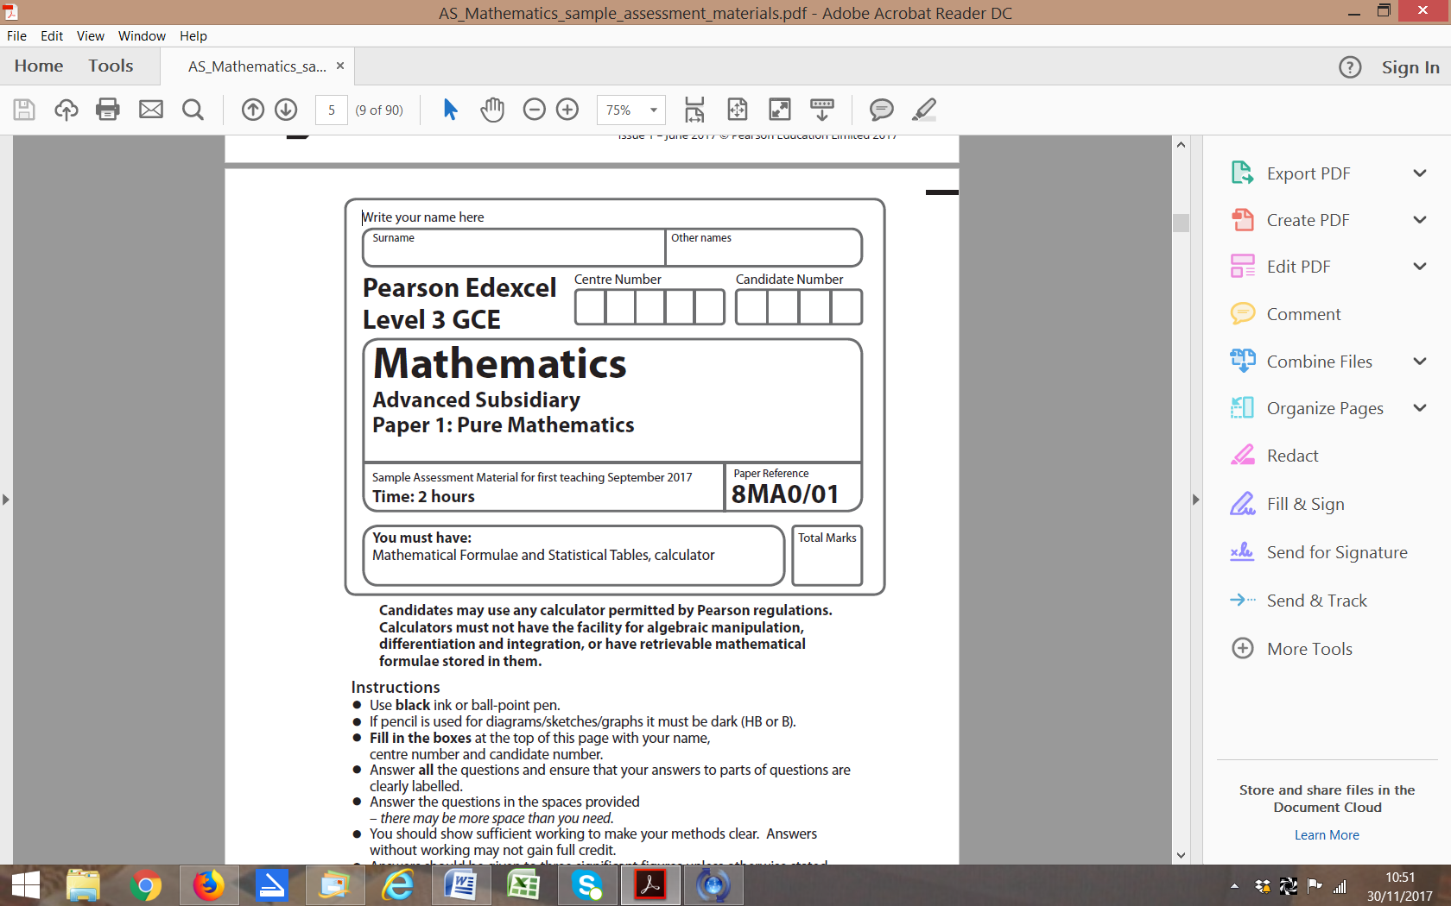

**Questions to revise:**

**1** Express  as a single fraction in its simplest form. **(4 marks)**

**2** Jacob is making some patterns out of squares. The first 3 patterns in the sequence are shown.

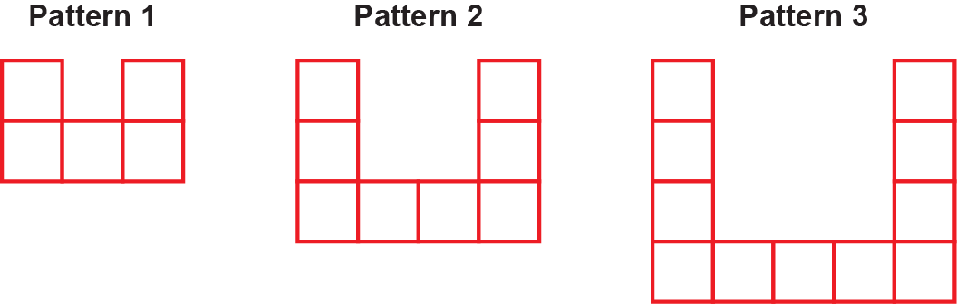

**a** Find an expression, in terms of *n*, for the number of squares required to make pattern *n.* **(2 marks)**

Jacob uses a total of 948 squares in constructing the first *k* patterns.

**b** Show that  **(2 marks)**

**3** , –40 < *x* < 20, *x* is in radians.

**a** Show that the equation g(*x*) = 0 can be written as  **(3 marks)**

**b** Using the formula, find, to 3 decimal places,

the values of *x*1, *x*2 and *x*3. **(2 marks)**

**4** **a** When *θ* is small, show that the equationcan be written as  **(4 marks)**

**b** Hence write down the value of  when *θ* is small. **(1 mark)**

**5** **a** Prove that the sum of the first *n* terms of an arithmetic series is  **(3 marks)**

**b** Hence, or otherwise, find the sum of the first 200 odd numbers. **(2 marks)**

**6** 

Find the values of the constants *A*, *B*, *C* and *D*. **(5 marks)**

**7** Prove by contradiction that there are infinitely many prime numbers. **(6 marks)**

**8** A curve has the equation

Show that the equation of the tangent at the point with an *x*-coordinate of 1 is

 **(6 marks)**

**9** 

**a** Find **(3 marks)**

**b** Evaluate, giving your answer in the form, where *m*, *n* and *p* are rational numbers. **(3 marks)**

**10 a** Show thatby expanding and

using the compound-angle formulae. **(3 marks)**

**b** Hence find **(3 marks)**

**11**

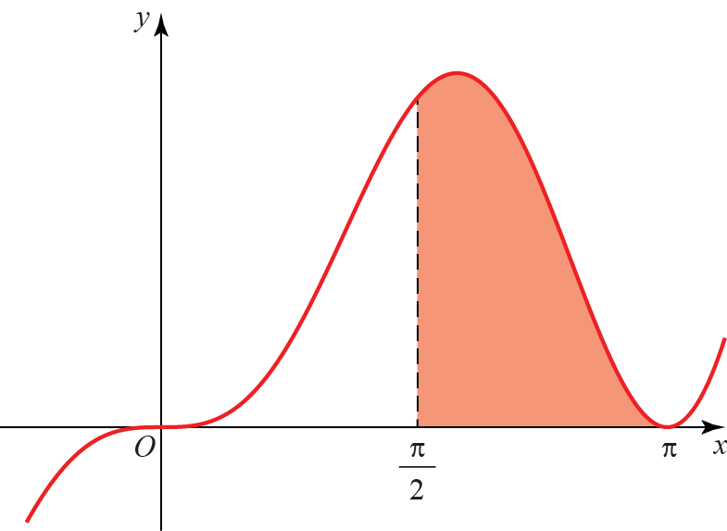

The diagram shows part of the curve with equation.

The finite region bounded by the line with equation, the curve and the *x*-axis is shown shaded in the diagram.

Find the area of the shaded region. **(7 marks)**

**12 a** Prove that  **(3 marks)**

**b** Use the result to solve, for, the equation 

Give your answer in terms of π. Check for extraneous solutions. **(4 marks)**

**13** , *x*∈ℝ

**a** Sketch the graph of *y* = f(*x*), labelling its vertex and any points of intersection with

the coordinate axes. **(5 marks)**

**b** Find the coordinates of the points of intersection of and **(5 marks)**

**14 a** Show that inwithand, 

to one decimal place. **(7 marks)**

**b** Hence findand. **(3 marks)**

**15** The diagram shows the curve *C* with parametric equations,, .

The curve passes through the *x*-axis at *P*.

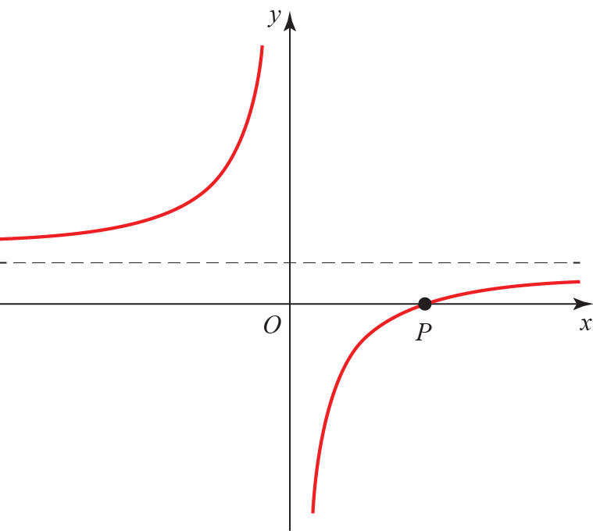

**a** Find the coordinate of *P*. **(2 marks)**

**b** Find the cartesian equation of the curve. **(2 marks)**

**c** Find the equation of the normal to the curve at the point *t =* −1.

Give your answer in the form  **(6 marks)**

**d** Find the coordinates of the point where the normal meets *C*. **(4 marks)**

**(TOTAL: 100 MARKS)**