|  |  |
| --- | --- |
| **Pearson Edexcel Level 3** | |
| **GCE Mathematics**  **Advanced Level**  **Paper 1 or 2: Pure Mathematics** | |
| **Practice Paper E**  **Time: 2 hours** | **Paper Reference(s)** |
| **9MA0/01 or 9MA0/02** |
| **You must have:**  **Mathematical Formulae and Statistical Tables, calculator** | |

**Candidates may use any calculator permitted by Pearson regulations. Calculators must not have the facility for algebraic manipulation, differentiation and integration, or have retrievable mathematical formulae stored in them.**

**Instructions**

• Use black ink or ball-point pen.

• If pencil is used for diagrams/sketches/graphs it must be dark (HB or B).

• Answer **all** questions and ensure that your answers to parts of questions are clearly labelled.

• Answer the questions in the spaces provided – *there may be more space than you need*.

• You should show sufficient working to make your methods clear. Answers without working may not gain full credit.

• Inexact answers should be given to three significant figures unless otherwise stated.

**Information**

• A booklet ‘Mathematical Formulae and Statistical Tables’ is provided.

• There are 14 questions in this paper. The total mark is 100.

• The marks for each question are shown in brackets – *use this as a guide as to how much time to spend on each question.*

**Advice**

• Read each question carefully before you start to answer it.

• Try to answer every question.

• Check your answers if you have time at the end.

• If you change your mind about an answer, cross it out and put your new answer and any working underneath.

**Answer ALL questions.**

**1.** Prove by exhaustion that  for positive integers from 1 to 6 inclusive.

**(3 marks)**

**___________________________________________________________________________________**

**2.** (a) When *θ* is small, show that the equationcan be written as .

**(4 marks)**

(b) Hence write down the value of  when *θ* is small.

**(1 mark)**

**___________________________________________________________________________________**

**3.** A stone is thrown from the top of a building. The path of the stone can be modelled using the parametric equations,, *t* ≥ 0, where *x* is the horizontal distance from the building in metres and *y* is the vertical height of the stone above the level ground in metres.

(a) Find the horizontal distance the stone travels before hitting the ground.

**(4 marks)**

(b) Find the greatest vertical height.

**(5 marks)**

**___________________________________________________________________________________**

**4.** Given that, find

(a) in terms of *y*.

**(2 marks)**

(b) Show that, where *k* is a constant which should be found.

**(3 marks)**

**___________________________________________________________________________________**

**5.** 

(a) Find.

**(3 marks)**

(b) Evaluate, giving your answer in the form , where *m*, *n* and *p* are rational numbers.

**(3 marks)**

**___________________________________________________________________________________**

**6.** Figure 1 shows a sketch of part of the graph *y* = f(*x*) where 

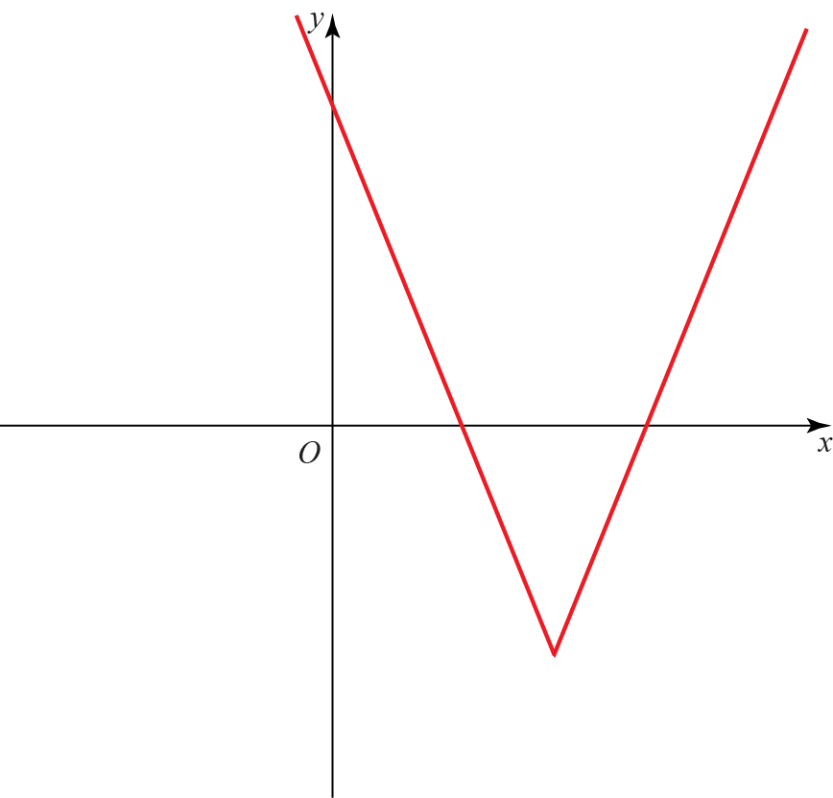

**Figure 1**

(a) State the range of f.

**(1 mark)**

(b) Given that , where *k* is a constant has two distinct roots, state the possible values of *k*.

**(7 marks)**

**___________________________________________________________________________________**

**7.** 

Show that f (*x*) can be written in the form , where *A*, *B* and *C* are constants to be found.

**(7 marks)**

**___________________________________________________________________________________**

**8.** A ball is dropped from a height of 80 cm. After each bounce it rebounds to 70% of its previous maximum height.

(a) Write a recurrence relation to model the maximum height in centimetres of the ball after each subsequent bounce.

**(2 marks)**

(b) Find the height to which the ball will rebound after the fifth bounce.

**(2 marks)**

(c) Find the total vertical distance travelled by the ball before it stops bouncing.

**(4 marks)**

(d) State one limitation with the model.

**(1 mark)**

**___________________________________________________________________________________**

**9.** Solve  in the range. Round your answer to 1 decimal place.

**(4 marks)**

**___________________________________________________________________________________**

**10.** Use proof by contradiction to show that there is no greatest positive rational number.

**(4 marks)**

**___________________________________________________________________________________**

**11.** The first three terms in the binomial expansion of  are .

(a) Find the values of *a* and *b.*

**(5 marks)**

(b) State the range of values of *x* for which the expansion is valid.

**(2 marks)**

(c) Find the value of *c*.

**(2 marks)**

**___________________________________________________________________________________**

**12.** The diagram shows a cuboid whose vertices are *O*, *A*, *B*, *C*, *D*, *E*, *F* and *G*. **a**, **b** and **c** are the vectors ,  and  respectively. The points *M* and *N* lie on *OA* such that . The points *K* and *L* lie on *EF* such that .

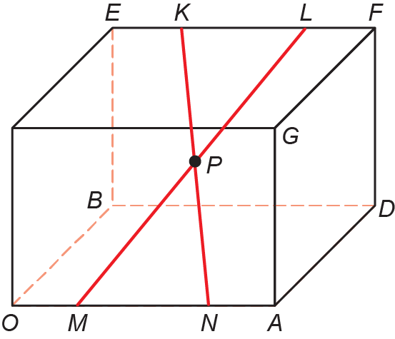

**Figure 1**

Prove that the diagonals *KN* and *ML* bisect each other at *P*.

**(10 marks)**

**___________________________________________________________________________________**

**13.** The value of a computer, *V*, decreases over time, *t*, measured in years. The rate of decrease of the value is proportional to the remaining value.

Given that the initial value of the computer is *V*0 ,

(a) show that.

**(4 marks)**

After 10 years the value of the computer is.

(b) Find the exact value of *k*.

**(3 marks)**

(c) How old is the computer when its value is only 5% of its original value? Give your answer to 3 significant figures.

**(3 marks)**

**___________________________________________________________________________________**

**14. **.

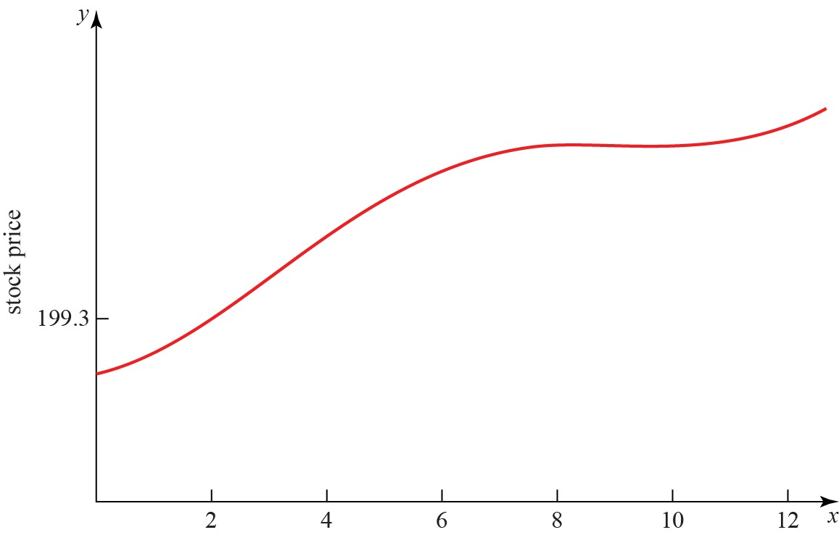

**Figure 3**

Figure 3 is a graph of the price of a stock during a 12-hour trading window. The equation of the curve is given above.

(a) Show that the price reaches a local maximum in the interval .

**(5 marks)**

Figure 3 shows that the price reaches a local minimum between 9 and 11 hours after trading begins.

(b) Using the Newton–Raphson procedure once and taking *t*0 = 9.9 as a first approximation, find a second approximation of when the price reaches a local minimum.

**(6 marks)**

**____________________________________________________________________________**

**TOTAL FOR PAPER IS 100 MARKS**